**GREEN AI COMPAROMETER**

**SYSTEM DESIGN**

1. **Architecture Type:**

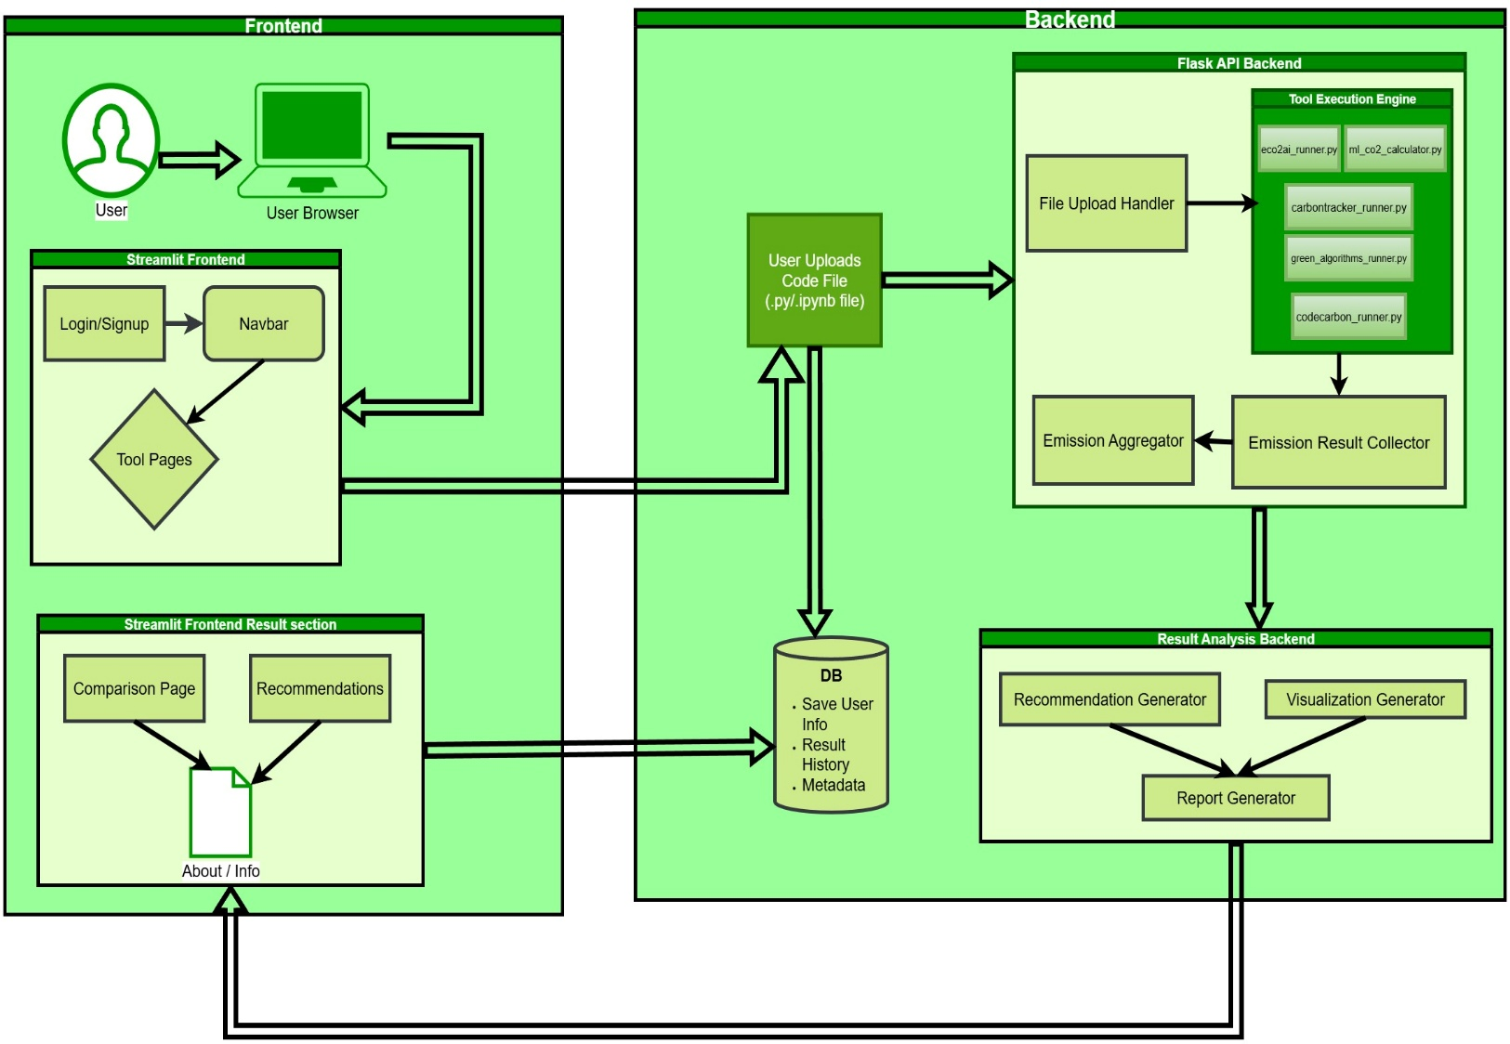

1. **Component Breakdown**

* **Frontend( Streamlit /UI)**

User file uploaded(.py/.ipynb)

**Displays:**

Emissions results per tool

Execution logs(console)

Downloadable CSV reports

Graphs: tool wise emission comparison

Suggestions for green coding

* **Backend Handlers**

**Each tool has its handlers:**

* + - eco2ai_runner.py
    - carbontracker_runner.py
    - codecarbon_runner.py

**Each Handler:**

* + - Converts .ipynb to .py if needed
    - Inserts code into the tracking wrapper
    - Executes and logs emissions
    - Returns JSON or CSV output
* **Database**
  + - Store each file’s result
    - Save past uploads
    - Create a history/log page for user

1. **Final recommendation panel:**

* "Most eco-friendly result"
* Emissions per tool for a code file
* Suggestions: GPU vs CPU usage, batch size, training time